Instruction to solve the case.

The Seven Steps of Problem Analysis
Using an organized seven-stem approach in analyzing a case will make the entire process easier and can increase your learning benefits.
- Read the case thoroughly. To understand fully what is happening in a case, it is necessary to read the case carefully and thoroughly. You may want to read the case rather quickly the first time to get an overview of the industry, the company, the people, and the situation. Read the case again more slowly, making notes as you go.
- Define the central issue. Many cases will involve several issues or problems. Identify the most important problems and separate them from the more trivial issues. After identifying what appears to be a major underlying issue, examine related problems in the functional areas (for example, marketing, finance, personnel, and so on). Functional area problems may help you identify deep-rooted problems that are the responsibility of top management.
- Define the firm’s goals. Inconsistencies between a firm’s goals and its performance may further highlight the problems discovered in step 2. At the very least, identifying the firm’s goals will provide a guide for the remaining analysis.
- Identify the constraints to the problem. The constraints may limit the solutions available to the firm. Typical constraints include limited finances, lack of additional production capacity, personnel limitations, strong competitors, relationships with suppliers and customers, and so on. Constraints have to be considered when suggesting a solution.
- Identify all the relevant alternatives. The list should all the relevant alternatives that could solve the problem(s) that were identified in step 2. Use your creativity in coming up with alternative solutions. Even when solutions are suggested in the case, you may be able to suggest better solutions.
- Select the best alternative. Evaluate each alternative in light of the available information If you have carefully taken the proceeding five steps, a good solution to the case should be apparent. Resist the temptation to jump to this step early in the case analysis. You will probably miss important facts, misunderstand the problem, or skip what may be the best alternative solution. You will also need to explain the logic you used to choose one alternative and reject the others.
- Develop an implementation plan. The final step in the analysis is to develop a plan for effective implementation of your decision. Lack of an implementation plan even for a very good decision can lead to disaster for a firm and for you. Don’t overlook this step. Your teacher will surely ask you or someone in the class to explain how to implement the decision.
A well-written report would contain the following elements:
- Executive summary. This is a concisely written statement, less than one page, placed at the front of the report. It briefly summarizes the major points of the case and your solution. It should describe the major issue, the proposed solution, and the logic supporting the solution.
- Problem statement. Present the central issue(s) or major problem(s) in the case here. Do not rehash the facts of the case; assume that anyone reading the report is familiar with the case.
- Alternatives. Discuss all relevant alternatives. Briefly present the major arguments for and against each alternative. Be sure to state your assumptions and the impact of constraints on each alternative.
- Conclusion. Present the analysis and the logic that led you to select a particular solution. Also discuss the reasons you rejected the other alternatives.
- Implementation. Outline a plan of action that will lead to effective implementation of the decision so that the reader can see not only why you chose a particular alternative but how it will work.
Example Case Question

- What steps can Wal-Mart take in the face of heavy market saturation to sustain their rapid expansion.

Background analysis (Using information found only in the case, no outside information allowed)
- Introduction of Walmart
- History of Walmart
- Present situation of Walmart

Problem Identification
- List and description of all the major problems that wal-mart is facing in the case

Analysis – [ BASED ON INFORMATION FROM THE CASE STUDY and What you learned in class for market and consumer analysis]
- SWOT analysis ( not bullet points but explanations of each point)
- Life Cycle Analysis of the PRODUCT and COMPANY [ USING suitable graph]
- Porters 5 Analysis [BASED on the case information]
- PESTEL analysis [Based on the case and the country in the case]

THREE alternative solution to solve the CASE problem and problems identified with pros and cons of each solution.
For example : Mergers with another company
Why it would be a good solution -
Pros –
Cons -

Implementation : Which solution you decide do go with and would suit the best to solve the problem for Walmart and how would you implement the solution.

Detailed Guideline
I. Introduction
Cases assists in bridging the gap between classroom learning and the so-called real world of management. They provide us with an opportunity to develop, sharpen, and test our analytical skills at:
- - Assessing situations.
- - Sorting out and organizing key information.
- - Asking the right questions.
- - Defining opportunities and problems
- - Identifying and evaluating alternative courses of action.
- - Interpreting data.
- - Evaluating the results of past strategies.
- - Developing and defending new strategies.
- - Interacting with other managers.
- - Making decisions under conditions of uncertainty.
- - Critically evaluating the work of others.
- - Responding to criticism.
The use of business cases was developed by faculty members of the Harvard Graduate School of Business Administration in the 1920s. Case studies have been widely accepted as one effective way of exposing students to the decision-making process.
Basically, cases represent detailed descriptions or reports of business problems. They are usually written by a trained observer who actually had been involved in the firm or organization and had some dealings with the problems under consideration. Cases generally entail both qualitative and quantitative data which the student must analyze and determine appropriate alternatives and solutions.
The primary purpose of the case method is to introduce a measure of realism into management education. Rather than emphasizing the teaching of concepts, the case method focuses on application of concepts and sound logic to real-world business problems. In this way the student learns to bridge the gap between abstraction and application and to appreciate the value of both.
The primary purpose of this paper is to offer a logical format for the analysis of case problems. Although there is no one format that can be successfully applied to all cases, the following framework is intended to be a logical sequence from which to develop sound analyses. This framework is presented for analysis of comprehensive management cases; however, the
process should also be useful for shorter cases, incidents, and problems.
II. A Case Analysis Framework
A basic approach to case analyses involves a four-step process. First, the problem is defined. Second, alternative courses of action are formulated to solve the problem. Third, the alternatives are analyzed in terms of their strengths and weaknesses; and fourth, an alternative is accepted and a course of action is recommended. This basic approach is quite useful for the student well versed in case analysis, particularly for shorter cases or incidents. However, for the newcomer this framework may well be inadequate and oversimplified. Thus, the following expanded framework and checklists are intended to aid the student in becoming proficient at case and problem analysis.
A. Analyze and Record the Current Situation
Whether the analysis of a firm’s problems in done by a manager, student, or paid business consultant, the first step is to analyze the current situation. This does not mean writing up a history of the firm but entails the type of analysis described below. This approach is useful not only for getting a better grip on the situation but also for discovering both real and potential problems – the central concern of any case analysis.
Phase 1: The environment. The first phase in analyzing a management problem or case is to consider the environment in which the firm is operating. The economic environment can have a decided effect on an industry, firm, and management program. For example, a depresses economy with high unemployment may not be an ideal situation for implementing a large price increase. The social and cultural environment also can have considerable effect on both multinational and domestic firms. For example, the advent of men’s hairstyling could be considered an appropriate reaction to today’s longer hairstyles, whereas a price reduction to stimulate demand for haircuts could well be inappropriate.
Phase 2: The industry. The second phase involves analysis of the industry in which the firm operates. This phase can be critical, particularly in terms of how the firm’s product is defined. A too- narrow definition of the industry and competitive environment can be disastrous not only for the firm but also for the individual analyzing the case. In appraising the industry, it is useful to first categorize it by the Standard Industrial Classification (SIC) and in terms of the accompanying list (figure 1). After initial definition and classification, attention should be paid to such factors as:
- Technology.
a. Level.
b. Rate of change.
c. Technological threats to the industry.
- Political-legal-social influences.
a. Trends an government controls.
b. Specific regulations.
c. Social responsibility pressure.
d. Consumer perceptions of industry.
- Industrial guidelines and trends.
a. Pricing policies.
b. Promotion.
c. Product lines.
d. Channels of distribution.
e. Geographic concentration.
f. Increases or declines in firms or profitability.
- Financial indicators
a. Financial ratios.
b. Working capital required.
c. Capital structure.
d. Sources and uses of funds. e. Sales.
f. Profitability.
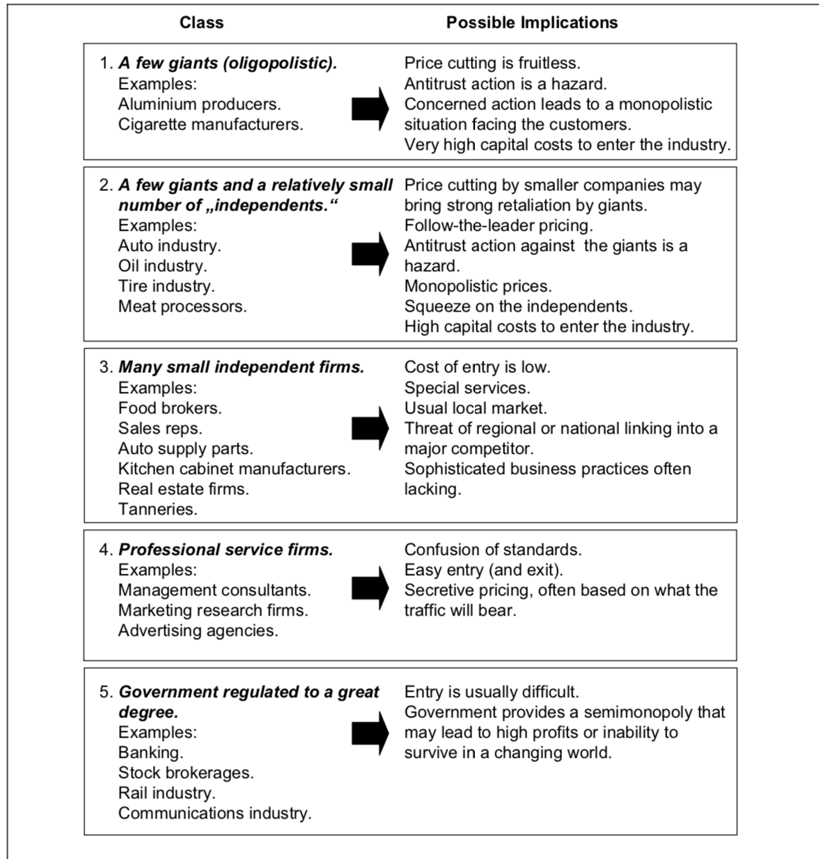

Figure 1: Industry classes
Phase 3: The firm. The third phase involves analysis of the firm itself not only in comparison with the industry and industry averages but also internally in terms of both quantitative and qualitative data. Key areas of concern at this stage are such factors as objectives, constraints, management philosophy, strengths, weaknesses, and structure of the firm.
Phase 4: The management program: Although there may be internal personnel or structural problems in the corporation itself that need examination, typically an analysis of the current corporate strategy is the next phase. In this phase the objectives of the firm are analyzed in terms of agreement, soundness, and attainability. Each element of the management toolbox as well as other areas, such as business research and information systems, is analyzed in terms of whether it is internally consistent and synchronized with the goals of the business unit and firm. Although cases often are labeled in terms of their primary emphasis, such as “Pricing” or “Advertising”, it is important for the student to analyze the corporate strategy and entire management toolbox, since a change in one element will affect the entire management program.
In performing the analysis of the current situation, the student should analyze the data carefully to extract the relevant from the superfluous. Many cases contain information that is not relevant to the problem, it is the student’s job to discard this information to get a clearer picture of the current situation. As the analysis proceeds, a watchful eye must be kept on each phase to determine (1) symptoms of problems, (2) current problems, and (3) potential problems. Symptoms of problems are indicators of a problem but are not problems in and of themselves. For example, a symptom of a problem may be a decline in sales in a particular sales territory. However, the problem is the root cause of the decline in sales – perhaps the field representative quit marketing sales calls and is relying on phone orders only.
The following is a checklist of the types of questions that should be asked when performing the analysis of the current situation.

Checklist for Analyzing the Current Situation
Phase 1: The environment.
- Are there any trends in the environment that could have an effect on the industry, firm, or management program?
- What is the state of the economy ? Inflation? Stagflation? Depression?
- What is the cultural, social, and political atmosphere?
- Are there trends or changes in the environment that could be advantageous or disadvantageous to the industry, firm, or management program? Can the management program be restructured to take advantage of these trends or changes?
Phase 2: The industry.
- What industry is the firm in? What class of industry? Are there other industries the firm is competing with?
- What is the size of the firm relative to the industry?
- How does the firm compare in terms of market share, sales, and profitability with the rest of the industry?
- How does the firm compare with other firms in the industry in terms of a financial ratio analysis?
- What is the firm’s major competition?
- Are there any trends in terms of government control, political, or public atmosphere that could affect the industry?
Phase 3: The firm.
- What are the objectives of the firm? Are they clearly stated? Attainable?
- What are the strengths of the firm? Managerial expertise? Financial? Copyrights or patents?
- What are the constraints and weaknesses of the firm?
- Are there any real or potential sources of dysfunctional conflict in the structure of the firm?
- How are the functional departments (e.g. marketing, financial services, controlling, HR...) structured in the firm?
- What is the corporate culture of the firm? What kind of management style is preferred? How do employees communicate?
Phase 4: The management program.
- What are the objectives of the management program? Are they clearly stated? Are they consistent with the objectives of the firm? Is the entire management toolbox structured to meet these objectives?
- What management concepts are at issue in the program? Is the management program well planned and laid out? Is the program consistent with sound management principles? If the program takes exception to management principles, is there a good reason for it?
- To what target market is the program directed? Is it well defined? Is the market large enough to be profitably served? Does the market have long-run potential?
- What competitive advantage does the management program offer? If none, what can be done to gain a competitive advantage in the market place?
- What products are being sold? What is the width, depth, and consistency of the firm’s product lines? Does the firm need new products to fill out its product line? Should any product be deleted? What is the profitability of the various products?
- What promotion mix is being used? Is promotion consistent with the products and product images? What could be done to improve the promotion mix?
- What channels of distribution are being used? Do they deliver the product at the right time and right place to meet consumer needs? Are the channels typical of those used in the industry? Could channels be made more efficient?
- What pricing strategies are being used? How do prices compare with similar products of other firms? How are prices determined?
- Are business research and information systematically integrated into the management program? Is the overall management program internally consistent?
- Are (senior/middle) managers capable to translate strategy into action? Are managers excellent in action or just in talking?
The relevant information from this preliminary analysis is now formalized and recorded. At this point the analyst must be mindful of the difference between facts and opinions. Facts are objective statements, such as financial data, whereas opinions are subjective interpretations of facts or situations. The analyst must make certain not to place too much emphasis on opinions and carefully consider any variables that may bias such opinions.
Regardless of how much information is contained in the case or how much additional information is collected, the analyst usually finds that it is impossible to specific a complete framework for the current situation. It is at this point that assumptions must be made. Clearly, since each analyst may make different assumptions, it is critical that assumptions be explicitly stated. One authority suggests that, when presenting a case, the analyst should distribute copies of the assumption list to all audience members. In this way confusion is avoided in terms of how the analyst perceives the current situation and how others can evaluate the reasonableness and necessity of the assumptions.
B. Analyze and Record Problems and Their Core Elements
After careful analysis, problems and their core elements should be explicitly stated and listed in order of importance. Finding and recording problems and their core elements can be difficult. It is not uncommon upon reading a case for the first time for the student to view the case as a description of a situation in which there are no problems. However, careful analysis should reveal symptoms, which lead to problem recognition.
Recognizing and recording problems and their core elements is most critical for a meaningful case analysis. Obviously, if the root problems are not explicitly stated and understood, the remainder of the case analysis has little merit since the true issues are not being dealt with. The following checklist of questions is designed to assist the student in performing this step of the analysis.
- What is the primary problem in the case? What are the secondary problems?
- What proof exists that these are the central issues? How much of this proof is based on facts? On opinions? On assumptions?
- What symptoms are there that suggest these are the real problems in the case?
- How are the problems, as defined, related? Are they independent or are they the result of a deeper problem?
- What are the ramifications of these problems in the short run? In the long run?
Checklist for Analyzing Problems and Their Core Elements
Checklist for Formulating and Evaluating Alternative Courses of Action
D.
- What possible alternatives exist for solving the firm’s problems?
- What limits are there on the possible alternatives? Competence? Resources?
Management preference? Social responsibility? Legal restrictions?
- What major alternatives are now available to the firm? What management concepts are
involved that affect these alternatives?
- Are the listed alternatives reasonable given in the firm’s situation? Are they logical? Are
the alternatives consistent with the goals of the management program? Are they
consistent with the firm’s objectives?
- What are the costs of each alternative? What are the benefits? What are the advantages
and disadvantages of each alternative?
- Which alternative best solves the problem and minimizes the creation of new problems
given the above constraints?
Select, Implement, and Record the Chosen Alternative Course of Action
Rasche/Seisreiner: Guidelines for Business Case Analysis
C. Formulate, Evaluate, and Record Alternative Courses of Action
This step is concerned with the question of what can be done to resolve the problem defined in the previous step. Generally, a number of alternative courses of action are available which could potentially help alleviate the problem condition. One authority suggests three to seven alternatives as a reasonable number of alternatives to work with. Another approach is to brainstorm as many alternatives as possible initially and then reduce the list to a workable number.
Sound logic and reasoning are particularly important in this step. It is critical to avoid alternatives that could potentially alleviate the problem but that at the same time create a greater new problem or require greater resources than the firm has at its disposal.
After serious analysis and listing of a number of alternatives, the next task is to evaluate them in terms of their costs and benefits. Costs are any output or effort the firm must exert to implement the alternative. Benefits are any input or value received by the firm. Costs to be considered are time, money, other resources, and opportunity costs, while benefits are such things as sales, profits, goodwill, customer and employee satisfaction. The following checklist provides a guideline of questions to be used when performing this phase of the analysis.
In light of the previous analysis, the alternative is now selected that best solves the problem with a minimal creation of new problems. It is important to record the logic and reasoning that precipitated the selection of a particular alternative. This includes articulating not only why the alternative was selected but also why the other alternatives were not selected.
No analysis is complete without an action-oriented decision and plan for implementing the decision. The accompanying checklist indicates the type of questions that should be answered in this stage of the analysis.
- What must be done to implement the alternative?
- What personnel will be involved? What are the responsibilities of each?
- When and where will the alternative be implemented?
- What will be the probable outcome?
- How will the success or failure of the alternative be measured?
III. Guidelines for an Operational Approach to Case and Problem Analysis
1. Read the case quickly to get an overview of the situation. 8/12
Checklist for Selecting and Implementing the Chosen Alternative
Rasche/Seisreiner: Guidelines for Business Case Analysis
- Read the case again thoroughly. Underline relevant information and take notes on potential areas of concern.
- Review outside sources of information on the environment and the industry. Record relevant information and the source of this information.
- Perform comparative analysis of the firm with the industry and industry averages.
- Analyze the firm.
- Analyze the management program.
- Record the current situation in terms of relevant environmental, industry, firm, and
management program parameters.
- Make and record necessary assumptions to complete the situational framework.
- Determine and record the major issues, problems, and their core elements.
- Record proof that these are the major topics.
- Record potential courses of actions.
- Evaluate each initially to determine constraints that preclude acceptability.
- Evaluate remaining alternatives in terms of costs and benefits.
- Record analysis of alternatives.
- Select an alternative.
- Record alternative and defense of its selection.
- Record the who, what, when, where, how, and why of the alternative and its
implementation.
IV. Pitfalls to Avoid in Case Analysis
Below is a summary of some of the most common errors analysts make when analyzing cases. When evaluating your analysis or those of others, this list provides a useful guide for spotting potential shortcomings.
- Inadequate definition of the problem. By far the most common error made in case analysis is attempting to recommend a course of action without first adequately defining or understanding the problem. Whether presented orally or in a written report, a case analysis must begin with a focus on the central issues and problems represented in the case situation. Closely related is the error of analyzing symptoms without determining the root problem.
- The search for “the answer”. In case analysis there are no clear-cut solutions. Keep in mind that the objective of case studies is learning through discussion, exploration, and the search for intelligent questions. There is no one “official” or “correct” answer to a case. Rather, there are usually several reasonable alternative solutions.
- Not enough information. Analysts often complain that there is not enough information in some cases to make a good decision. However, there is justification for not presenting “all” of the information in a case. As in real life, a manager or consultant seldom has all the information necessary to make an optimal decision. Thus, reasonable assumptions have to be made, and the challenge is to find intelligent solutions in spite of the limited information.
- Use of generalities. In analyzing cases, specific recommendations are necessarily not generalities. For example, a suggestion to increase the price is a generality, a suggestion to increase the price by $1.07 is a specific.
- A different situation. Considerable time and effort are sometimes exerted by students contending that “If the situation were different, I’d know what course of action to take” or “If the marketing manager hadn’t already fouled things up so badly, the firm wouldn’t have a problem”. Such reasoning ignores the fact that the events in the case have already happened and cannot be changed. Even though analysis or criticism of past events is necessary in diagnosing the problem, in the end, the present situation must be addressed and decisions must be made based on the given situation and the future.
9/12
Rasche/Seisreiner: Guidelines for Business Case Analysis
- Narrow vision analysis. Although cases are often labeled as a specific type of case, such as “Pricing”, “Product”, “Personnel” and so forth, this does not mean that other variables should be ignored. Too often students ignore the effects that a change in one management element (e.g. investment) will have on the others (e.g. financing).
- Realism. Too often analysts become so focused on solving a particular problem that their solutions become totally unrealistic. For example, suggesting a $1 million advertising program for a firm with a capital structure of $50,000 is an unrealistic solution.
- The business research solution. A quite common but unsatisfactory solution to case problems in business research, for example, “The firm should do this or that type of business research to find a solution to their problem.” Although business research may be helpful as an intermediary step in some cases, business research does not solve problems or make decisions. In cases where business research is recommended, the cost and potential benefits should be fully specified in the case analysis.
- Rehashing the case material. Analysts sometimes spend considerable effort rewriting a two- or three-page history of the firm as presented in the case. This is unnecessary since the instructor and other students are already familiar with this information.
10. Premature conclusions. Analysts sometimes jump to premature conclusions instead of waiting until their analysis in completed. Too many analysts jump to conclusions upon first reading the case and then proceed to interpret everything in the case as justifying their conclusions, even factors that are logically against it.
V. Communicating Case Analyses
The final concern in case analyses deals with communicating the results of the analysis. The most comprehensive analysis has little value if it cannot be communicated effectively. There are two primary media through which case analyses are communicated – the written report and the oral presentation.
A. The Written Report
Since the structure of the written report will vary by the type of case analyzed, the purpose of this section is not to present a “one and only” way of writing up a case. The purpose of this section is to present some useful generalizations to aid the student in case write-ups.
First, a good written report generally starts with an outline. The purpose of the outline is to:
- Organize the case material in a sequence that makes it easy for the reader to follow.
- Highlight the major thoughts of the case and show the relationships among subsidiary ideas and major ideas.
- Reinforce the student’s memory of the case ideas and provide the framework for developing these ideas.
- Serve to refresh the student’s memory of the case when it has to be referred to weeks later.
The outline format should avoid too fine a breakdown, and there should be at least two
subdivisions for any heading. The following is an example of typical headings:
I. Current Situation.
A. Environment.
1. Economic.
2. Cultural and social.
3. Political and legal. B. Industry.
10/12
Rasche/Seisreiner: Guidelines for Business Case Analysis
- Definition.
- Classification.
- Technology.
- Political-legal-social factors.
- Industrial guidelines and trends.
- Financial indicators.
C. Firm.
- Objectives.
- Constraints.
- Management philosophy.
- Strengths.
- Weaknesses.
- Structure.
7. Culture.
D. Management program. 1. Objectives.
2. Constraints.
3. Strengths.
4. Weaknesses.
5. Target market(s).
6. Product considerations. 7. Promotion considerations. 8. Pricing considerations.
9. Channel considerations.
10. Information and research considerations. 11. Managerial capabilities.
E. Assumptions about current situation. II. Problems.
A. Primary problem(s) 1. Symptoms.
2. Proof.
B. Secondary problem(s)
1. Symptoms.
2. Proof.
III. Alternatives.
A. Alternative 1.
1. Strengths and benefits.
2. Weaknesses and costs. B. Alternative 2.
1. Strengths and benefits
2. Weaknesses and costs. C. Alternative 3.
1. Strengths and benefits. 2. Weaknesses and costs.
11/12
Rasche/Seisreiner: Guidelines for Business Case Analysis
IV. Decision and Implementation.
A. What. B. Who. C. When. D. Where. E. Why. F. How.
V. Technical Appendix.
Writing the case report now entails filling out the details of the outline in prose form. Clearly, like any other skill, it takes practice to determine the best method for writing a particular case. However, simplicity, clarity, and precision are prime objectives of the report.
B. The Oral Presentation
Case analyses are often presented by an individual or team. As with the written report, a good outline is critical, and it is often preferable to hand out the outline to each audience member. Although there is no best way to present a case or to divide responsibility between team members, simply reading the written report in unacceptable, since it encourages boredom and interferes with all-important audience discussion.
The use of visual aids can be quite helpful in presenting class analyses. However, simply presenting financial statements contained in the case is a poor use of visual media. On the other hand, graphs of sales and profit curves can be more easily interpreted and can be quite useful for making specific points.
Oral presentation of cases is particularly helpful to students for learning the skill of speaking to a group. In particular, the ability to handle objections and disagreements without antagonizing others is a skill worth developing.
VI. Conclusion
From the discussion it should be obvious that good case analyses require a major commitment of time and effort. Individuals must be highly motivated and willing to get involved in the analysis and discussion if they expect to learn and succeed in a course where cases are utilized. Persons with only passive interests who perform “night before” analyses cheat themselves of valuable learning experiences which can aid them in their careers.

